**Phase 5**

**Lesson 3**

**Create a Bucket**

Steps :

This lab has eight subsections, namely:

1. Selecting S3 from the storage of the AWS service panel

2. Verifying the button to create a bucket

3. Providing a bucket name and region

4. Entering key and value for identification and tracking the bucket

5. Blocking all the public access

6. Reviewing all parameters and creating the bucket

7. Verifying the newly created bucket on the panel of S3

Step 1:

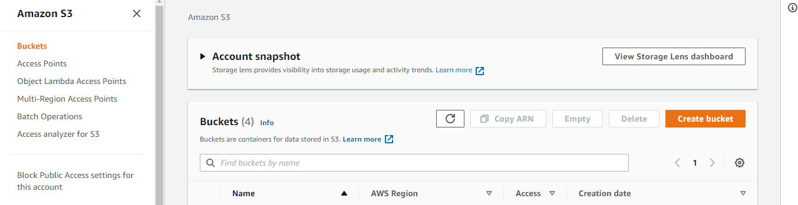

Step 2:

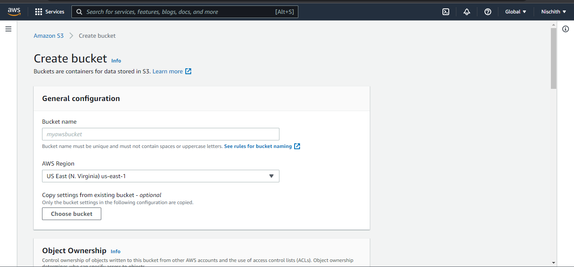

Step 3:

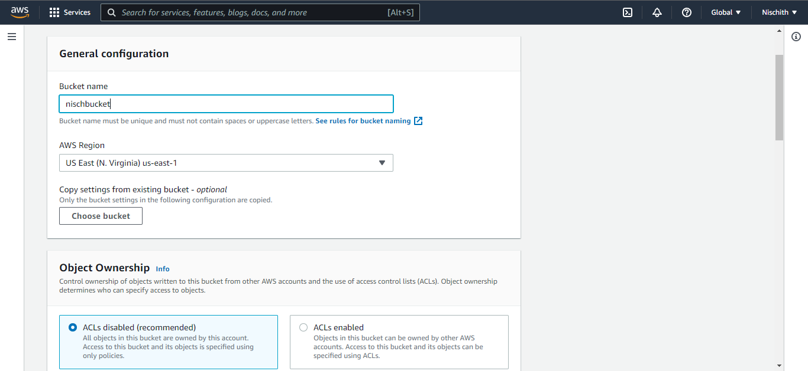

Step 4/5:

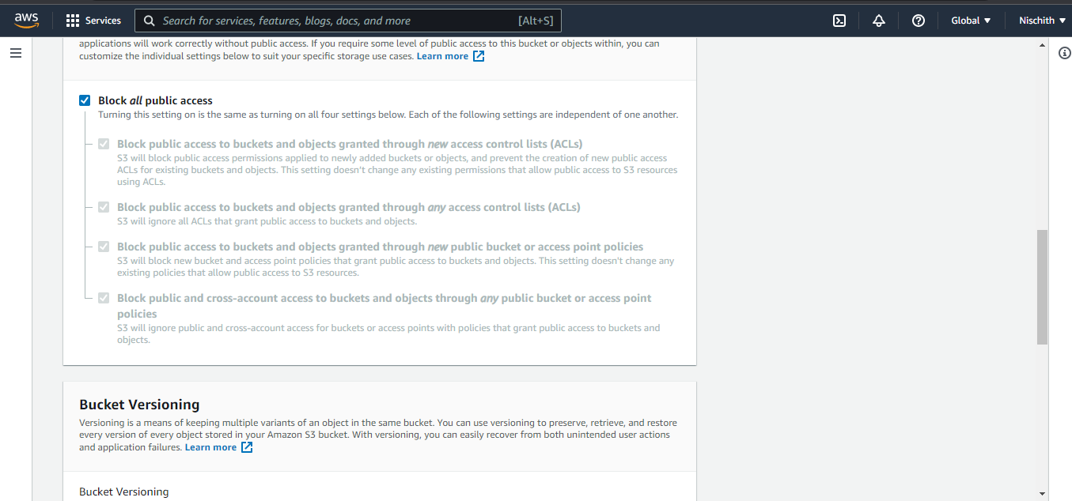

Step 6:

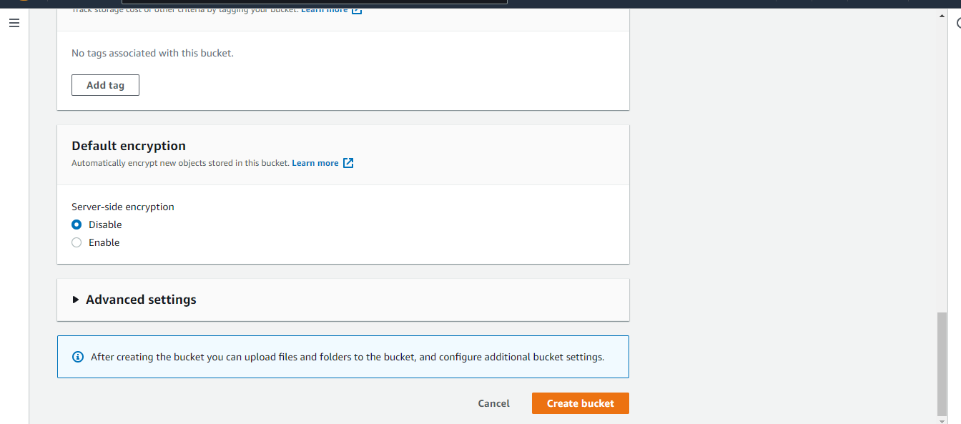

Step 7:

